Specialization : Finance

Academic Credentials
Course | Institute /Affiliating Board | Year of Passing | Percentage(%)
M.M.S. | Rizvi Institute of Management Studies & Research | 2015-2017 | Pursuing
M.Com (I) | Mumbai University | 2014-2015 | 54.50
B.Com. | Gonsalo Garcia College | 2014 | 82.14
H.S.C. | Maharashtra State Board | 2011 | 66.66
S.S.C. | Maharashtra State Board | 2009 | 72.61

Summer Internship Project
Organization | : | SBI Funds Management PVT LTD.
Title | : | Fundamental Factors of Stock Selection Under Alternative Investment Funds
Objective | : | Evaluating Investment opportunities in SME (Small and Medium Enterprises) sector by analyzing companies performance.

Academic Projects
Title | : | Valuatio of Cipla.
Objective | : | To Value Cipla Using DCF Method and Relative Method.
Title | : | Project on CIBIL
Objective | : | To Understand the Operrations, Features and Working of CIBIL.
Title | : | Accounting Concepts and Conventions.
Objective | : | Self Study on the accounting Concepts and Conventions.

Extra Curricular Activities
- Received Certificate of Participation in Marathon 2012.
- Received Certificate of Participation in Marathon 2011.

Personal Information
Date of Birth | 02nd December, 1993 | 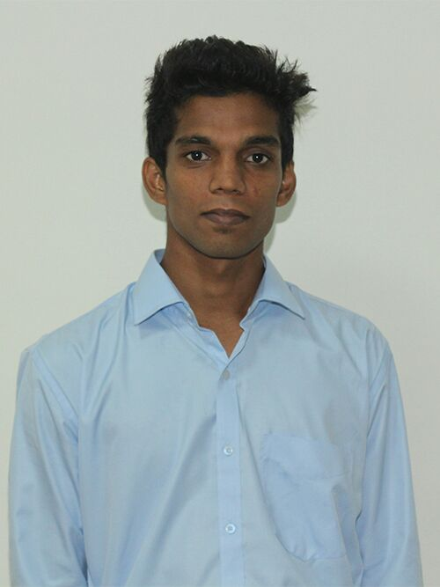
Marital Status | Single
Email | Parvez.gadwal@rmi.rizvi.edu.in
Mobile No. | +91 9561248697
Address | B-102,Pleasant Park-II,Behind Philips Complex,  BhabolaPapdy Road, Vasai (West). Thane-401207

Date:

Place:Mumbai

